Documentation of Changes to my Portfolio Website



Previously I didn’t add where I got my highest grades from which caused a bit of uncertainty so I decided to add where I got them from into the site



Did the same with the education & Certifications section

Changes 2 Fixing of staticness on the website

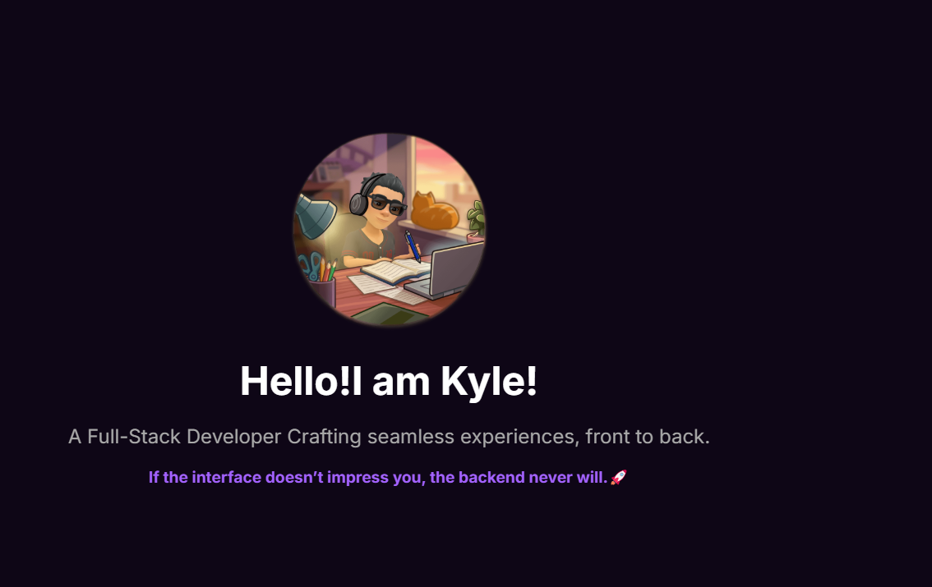

I was quite annoyed by how basic and static this looked so I decided to add in something quite unique to make this section stand out and grab your attention

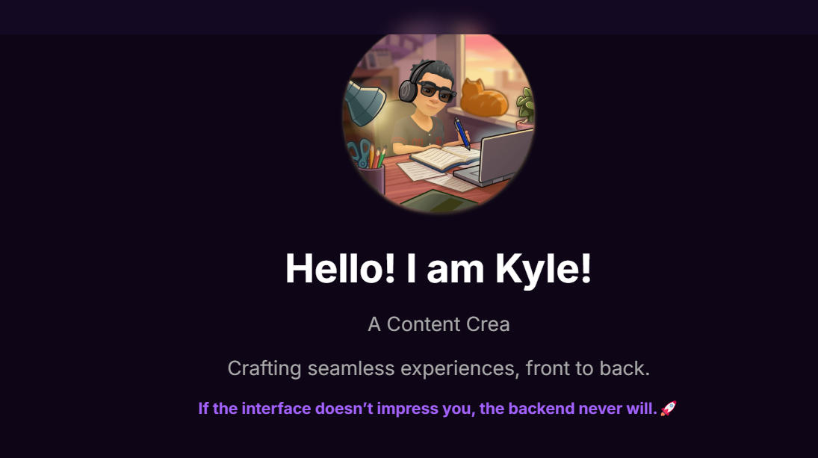

So now it types it out and erases to everything I consider myself to be

Third Issue

I absolutely hated my footer from the ghetto. Like Just look at this man

Absolutely horrible

So I fixed that with some svgs and some tweaking a boom

We have this

Massive difference and more professional

I’m still a bit iffy on the sizing but for now that’s a huge improvement and I’m sticking to it. SVGS for the win

But for now that’s the key issues I really noticed and I rectified them so yeah let me know if you find any bugs or see any issues I should fix